Oracle Real Application Clusters (RAC)
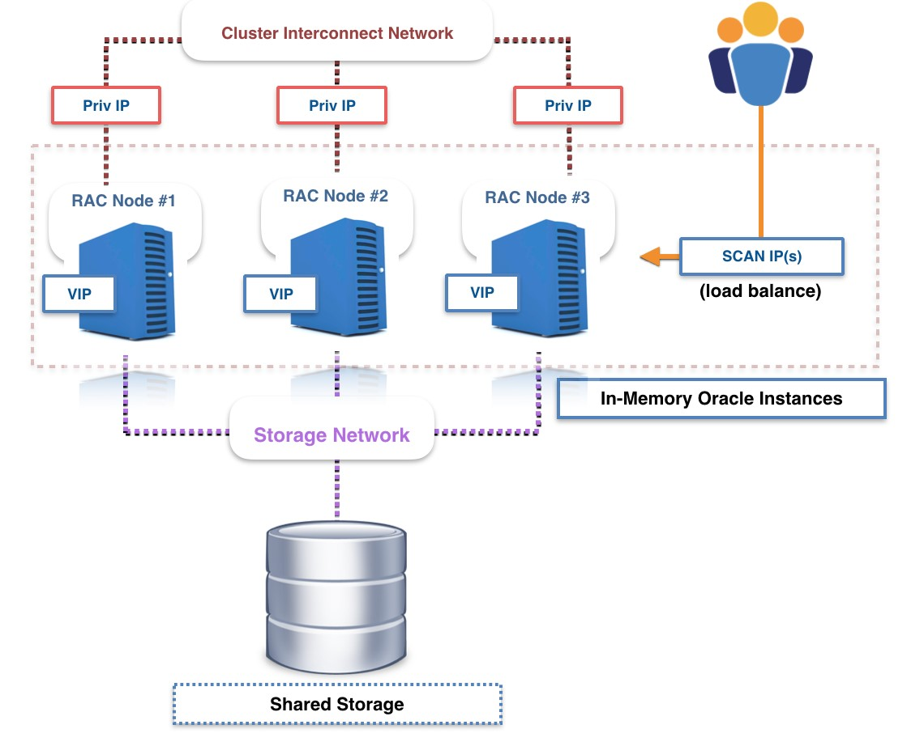
Oracle Real Application Clusters (RAC) is a "share-everything" architecture that enables multiple Oracle database instances, running on separate servers (nodes), to concurrently access a single, shared storage database. This design provides high availability, scalability, and performance for critical applications.
Multiple Oracle Instances:
- Each node in the RAC cluster runs its own Oracle instance, which includes its own System Global Area (SGA) and background processes.
Shared Storage:
- All nodes in the cluster access a common set of database files (data files, control files, redo log files, etc.) residing on shared storage, typically a Storage Area Network (SAN) or Network Attached Storage (NAS) or ASM.
RAC Interconnect: Private Interconnect & Public Interconnect
Private Interconnect:
- A dedicated, high-speed private interconnect network, communicates between the Oracle instances on different nodes. This is crucial for global resource management.
- UDP (User Datagram Protocol) is used as protocol.
Public Interconnect:
- This is the standard network interface used for client connections and external communication.
Load Balancing:
- load balancing is all about distributing database workloads efficiently across multiple nodes to ensure optimal performance, high availability, and resource utilization. Think of it like traffic control for your database connections—making sure no single node gets overwhelmed while others sit idle.
- If there are 50 connections 25 will be allocated to node 1 and 25 to node 2.

Transparent Application Failover:
- TAF automatically reconnects a user's session to another available RAC node if the original connection is lost due to a failure. This reconnection is transparent to the application, meaning users often don’t even notice the switch.
- Reconnect happens only after failure.
- A backup connection is pre-established, allowing faster failover.

Horizontal Scaling and Vertical Scaling:
Vertical Scaling:
- This means adding more power to an existing servers.
- How it works: You upgrade the server's CPU, RAM, or storage.
- Example: Going from 8 GB RAM to 32 GB RAM on the same server.
Horizontal Scaling:
- This means adding more servers (nodes) to your system.
- How it works: You add more servers or nodes and distribute the load.
- Example: Instead of 2 powerful servers, you use 5 smaller servers with a load balancer.

Cluster:
- A cluster refers to a group of interconnected nodes that work together as a single system to perform tasks more efficiently, reliably, and at scale.
- Each node in a cluster has its own CPU, memory, and storage, but they collaborate to:
- Share workloads
- Improve performance
- Ensure high availability
- Provide fault tolerance
- From the outside, a cluster often behaves like one unified machine, even though it's made up of many.

